CHRISTMAS SERVICE BEFORE MIDNIGHT MASS
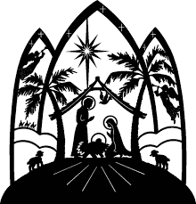

WELCOME and OPENING PRAYER
Let us pray to Christ, whom the Scriptures foretold, and whose coming we await in this holy season: COME, LORD JESUS OUR SAVIOUR.

Lord, the Prophet Isaiah foretold that the spirit of the Lord would rest upon You -
COME TO US BRINGING WISDOM AND UNDERSTANDING

The spirit of counsel and power was given to You;
MOVE THE HEARTS OF ALL WHO GOVERN OR RULE IN OUR WORLD TODAY.

You took on our human weakness;
BE THE EYES OF THE BLIND, THE STRENGTH OF THE WEAK,
THE FRIEND OF THE LONELY.

Your birth bound heaven to earth in harmony and peace;
ESTABLISH THAT SAME PEACE AMONG NATIONS, COMMUNITIES & FAMILIES.

O come, O come, Emmanuel,
And ransom captive Israel,
That mourns in lonely exile here,
Until the Son of God appear.
Rejoice! Rejoice! Emmanuel
Shall come to thee, O Israel.

O come, Thou Key of David, come
And open wide our heav'nly home;
Make safe the way that leads on high,
And close the path to misery.
Rejoice! Rejoice! Emmanuel
Shall come to thee, O Israel.

THE LIGHTING OF ADVENT CANDLES
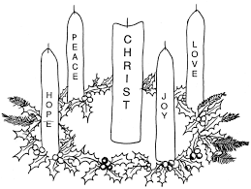

CANDLES OF HOPE AND LOVE WITH READING

CHILD IN A MANGER (Hymn 105)
Child in a manger! Infant of Mary, outcast and stranger, Lord of all!
Child who inherits all our transgressions, all our demerits on him fall!

Once the most holy child of Salvation, gentle and lowly lived below;
Now as our glorious mighty Redeemer, see Him victorious o'er each foe.

Prophets foretold Him, infant of wonder; angels behold him on His throne;
Worthy our Saviour of all their praises, happy for ever are His own.

CANDLES OF JOY AND PEACE WITH READING

O LITTLE TOWN OF BETHLEHEM (No 540)
O little town of Bethlehem, How still we see thee lie!
Above thy deep and dreamless sleep the silent stars go by.
Yet in thy dark streets shineth, the everlasting light;
The hopes and fears of all the years are met in thee to-night.

How silently, how silently, the wondrous gift is given;
So God imparts to human hearts the blessings of His heaven.
No ear may hear His coming, but in this world of sin,
Where meek souls will receive Him still, the dear Christ enters in.

LIGHTING OF CHRISTMAS CANDLE: (Ave Maria MUSIC )

As we light our Christmas Candle we pray for one another, for our families and friends, our parish priest
and the whole parish community
that the most precious gifts of all:
the gifts of FAITH AND LOVE
will indeed abound in our hearts and homes this Christmastide
and in each day of the new year that lies ahead.

SHORT PERIOD OF SILENCE BEFORE MASS

