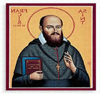 |  | ROMAN CATHOLIC ARCHDIOCESE OF SOUTHWARK |  |  |  |  |  | 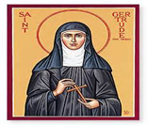
 |  | ST FRANCIS DE SALES & ST GERTRUDE CHURCH
 |  | 26 LARKHALL LANE, STOCKWELL, LONDON, SW4 6SP
 |  | PHONE: 020 7622 1621 E-MAIL: stockwell@rcaos.org.uk
 |  | Parish Website: www.stfrancischurch-stockwell.org.uk
31st March 2024: Easter Sunday (Year B)
1st Reading: Acts 10:34, 37-43; Psalm: 117; 2nd Reading: Colossians 3: 1-4; Gospel: John 20: 1-9
2nd Collection: |  |  |  |  |  |  | NEXT (21st April): Priests Training Fund
DAY | TIME | INTENTIONS |  |  |  |  | PASTORAL TEAM | ORDER OF MASS
Sat-30th | 18.30 | People of the Parish |  |  |  |  | Fr Michael Faneye, MSP: Parish Priest  Mr Charles Madden: PPC Chair  Mrs Catherine Biney: Finance  Mrs Folasade Onile-Ere: Catechist  Mr Patrick Sanniez: Sacristan  Mrs Lanike T. Onikosi: Maintenance  Ms Clara-Mary Senghore: Office Admin  Office Hours:  Tuesdays & Thursdays 10am – 2pm | I Confess | p.8
Sun-31st | 9.00 | Anosike Family Thanksgiving |  |  |  |  |  | 1st Reading | 251  253
 | 11.00 | Anosike Family Thanksgiving |  |  |  |  |  | Resp. Psalm
Mon-1st | NO MASS |  |  |  |  |  |  | 2nd Reading
Tue-2nd | 09.30 |  |  |  |  |  |  | Gospel
Wed-3rd | 09.30 |  |  |  |  |  |  | I believe in | P.11
Thu-4th | 09.30 |  |  |  |  |  |  | Our Father | p.43
Fri-5th | 09.30 |  |  |  |  |  | ANNOUNCEMENTS
Sat-6th | 20.00 | Martin & Kate Folan RIP, Birthday Thanksgiving, Beatrice Manufor RIP
Sun-7th | 9.00 | People of the Parish |  |  |  |  | 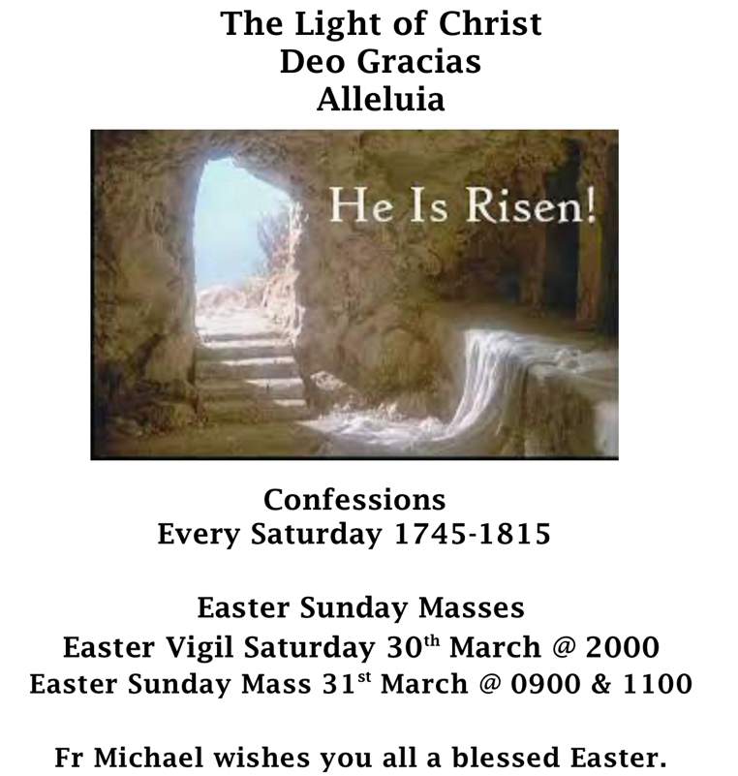  LOVE HEALS - BODY MIND and SPIRIT MINISTRY  Welcome you to come to a day Retreat of quiet Reflection. Saturday 6th April 2024. 11:00am – 4:30pm.  The Catholic Church of our Lady of Assumption & St Gregory. Warwick Street, Piccadilly, W1F 9JR  Publication of Banns of Marriage – Alexander Nyasing’a Monari, son of Michael Ombabah Monari and Eva Lanket Monari wishes to marry Zipporah Wanjiru Maruvu, daughter of Abyuo Maruvu Kamau and Esther Muthoni Maruvu.  If anyone knows why these two should not get married, please contact the parish priest.
 | 11.00 | Beatrice Manufor RIP
PARISHIONER BIRTHDAYS
30th Mar
31st Mar | Thelma Nutakor
1st April | Justice Biney
2nd April
3rd April | Maria Mendez
4th April | Madeleine E. L. Riley Smith
5th April
PLEASE KEEP IN YOUR PRAYERS
Crystal L, Andrew O’Neill, Patrick Idama, Michelle Martin, Michael McGrath, Eileen Kearns and all our sick and housebound parishioners.
OFFERTORY COLLECTION — 24/03/2024
Gift Aid |  |  | Loose | Total
£194.00 |  |  | £379.47 | £573.47
STANDING ORDERS/DIRECT DEBIT
Offerings can be made by envelope, contactless machine, direct debit or standing order:
RCAS STOCKWELL
NATWEST ACCOUNT NO 28975553
SORT CODE 60-20-31
MASS INTENTIONS
Please book mass for your intentions for family members, friends, birthdays, loved ones, the deceased and other intentions via the envelopes in the entry way of the church or send an email to the church office:
stockwell@rcaos.org.uk
INDEED, HE IS RISEN, ALLELUIA!


